Data Flow Diagram & User Stories

Date | 03 February 2026
Team ID | LTVIP2026TMIDS24613
Project Name | DocSpot: Seamless Appointment Booking for Health
Maximum Marks | 4 Marks

Data Flow Diagrams:
A Data Flow Diagram (DFD) illustrates how data moves within the Freelance Finder platform. It captures how users (freelancers and clients) interact with the system, how information flows between different components, and where the data is stored.
As a Patient, I want to:
- Register and log in securely so I can access my appointments.
- Search for doctors based on specialty, location, and availability to find the right match for my needs.
- Book an appointment by choosing a convenient time and uploading my medical reports.
- View my booking history and track the status of upcoming appointments.
- Reschedule or cancel appointments if my plans change.
- Receive reminders for my upcoming visits via SMS or email.
- Leave a review after my consultation to share my experience.
As a Doctor, I want to:
- Register and create a professional profile with specialization and experience details.
- Set my available time slots so patients can book accordingly.
- View appointment requests and confirm or reject them.
- Access uploaded patient documents before the consultation.
- Add visit notes or digital prescriptions for future reference.
- Manage my daily schedule from a personal dashboard.
As an Admin, I want to:
- Review and approve doctor registrations to maintain platform integrity.
- Monitor bookings and user activity from an admin dashboard.
- Remove or suspend users in case of rule violations or issues.
- View platform analytics like appointment volume or doctor activity.
- Handle user disputes or flagged bookings efficiently.

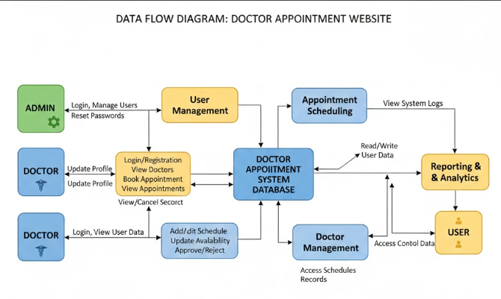
User Stories – DocSpot Appointment Booking App

User Role
User Story ID
User Story

Patient | US-P1 | As a patient, I want to register and log in securely so I can  manage my appointments.
Patient | US-P2 | As a patient, I want to search for doctors by specialty and  location to find the right one.
Patient | US-P3 | As a patient, I want to book appointments with available  doctors based on my preferred time.
Patient | US-P4 | As a patient, I want to upload medical documents during  booking so doctors are better prepared.
Patient | US-P5 | As a patient, I want to receive reminders so I don't miss  my appointments.
Patient | US-P6 | As a patient, I want to cancel or reschedule appointments  when needed.
Patient | US-P7 | As a patient, I want to leave a review after my  appointment to share feedback.
Doctor | US-D1 | As a doctor, I want to register and set up my profile  including specialization and fees.
Doctor | US-D2 | As a doctor, I want to manage my availability to control  when patients can book me.
Doctor | US-D3 | As a doctor, I want to view and approve or reject  appointment requests.
Doctor | US-D4 | As a doctor, I want to view patient-uploaded documents  to prepare for consultations.
Doctor | US-D5 | As a doctor, I want to provide digital prescriptions or  consultation summaries after appointments.
Admin | US-A1 | As an admin, I want to review and approve doctor  registrations for platform safety.
Admin | US-A2 | As an admin, I want to manage users and resolve disputes  efficiently.
Admin | US-A3 | As an admin, I want to monitor platform activity through  an oversight dashboard.

